Covid-19 Data Analysis Report

By:

Nalini Macharla

07/04/2021

**Introduction**

In 2020-2021, the whole world is suffering the covid pandemic. In the USA, we have 33 million cases since 2020, and 593,000 deaths. In Massachusetts, we have 708,000 confirmed cases and 17.9 thousand deaths. At the beginning of this year, the US government kept promoting vaccines, and the knowledge of COVID improved. This pandemic already can have an optimistic view than last year. In this report, we will use COVID data from the Massachusetts government to analyze and provide some advice for the student health center at any university. Firstly, points are listed that explains the business questions. Next, we have developed visualizations to support the decision-making process and to answer business questions. In the end, this project will focus on all the student health centers to see how the decision-making strategy designing process can be improved using such public health data to provide decision support not only for COVID but also for future health-related issues and epidemics.

**Business Case and Objectives**

The data we obtained from the mass.gov website about covid reporting. It contains multiple tabs for different kinds of attributes. This data has a couple of important factors on multiple aspects of public health. We created four dashboards to see through this COVID pandemic. The topics for these dashboards include the case study based on geography versus death cases, vaccinated with population situations, quarantine & isolate situation, positive rate, age, and medical usage situation. With this information, we can understand the real situations about how the Massachusetts State reacts to this pandemic and provide some insights about how the situation will be for us. In addition, it will help us to answer a broad spectrum of questions for the Student Health Centre.

**Data Visualization & Its Importance**

By creating an interactive dashboard for the COVID-19 data, we will be able to see the granular level of data such as desired month, or age group, with any such filters we will be able to view targeted age groups or targeted months visualizations. For example, if we consider the below graph, we have the age dropdown as a filter.

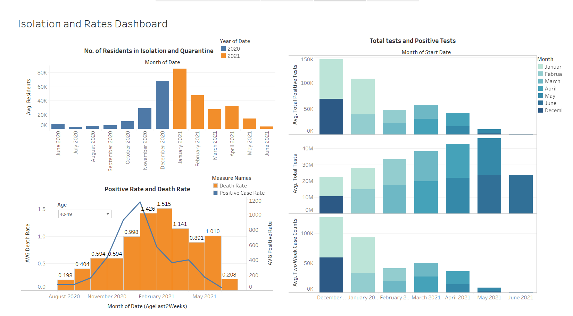

Here, we wanted to compare the positive case rate and death rate amongst those positive cases. Here, the blue trend line shows us the positive case rate. We have used the dropdown filter for ‘Age’ here, where we can select a particular age group for example, if we select age group of 30-39 or 40-49, we can see the individual positive cases rate and death rates in the same way, from the dropdown we can compare and see the death rates of different age groups in comparison with positive case rate. By our analysis, we can say that younger age groups have greater immunization against the virus compared to those who fall under higher age groups.

Due to this filter, we can differentiate the results with respect to age groups. If we do not have such a result, we can only view the cumulative result because of which we will not be able to differentiate and see which age group has been affected the most.

**Key Matrices**

The data is very vast and has bifurcation and classifications under several categories such as testing data, positive rates data, death related data, vaccination progress data etc. For designing the dashboard, we referenced the dashboard created by Massachusetts Department of Public Health. We selected Testing, Confirmed cases, death cases, hospitalization figures, vaccinated figures, isolation and quarantine numbers. We then took these matrices and factored them based on gender, age group, county and city, race and ethnicity, month of year during covid period etc. These factors were applied to the dashboard as filters which will help observe the data closely on smaller scales and make an easy comparison. Further, we also utilized the educational data which shows daily testing and positive rate or confirmed cases daily particularly for educational institutions. This matrix was then compared with daily state level data of covid cases and positive rate to see how rise and fall in overall Massachusetts cases affect cases between student communities in universities and colleges.

These matrices and comparisons between them will help student health centers make key decisions among others such as reopening of campus.

**Strategy and Recommendations**

While performing the exploratory data analysis, it was seen that the distribution of population varies across different factors like age, gender, race, county, and few others even for being fully vaccinated. This check can help move ahead for the Covid vaccination planning and analysis on a massive scale. The dashboard helps to reflect the distribution across number of tests, average new cases/ deaths, availability of hospitals, along with vaccination insights like- fully vaccinated population and footfall more which are yet to go for a second dose. For age groups with the age of 30-49 years and 50-64 have a greater percentage of being vaccinated as compared to other age groups. For most of the section being white followed by others like Hispanic and Asian. Finally, it is seen as per distribution across gender women seem to have a heavy fall for vaccination as opposed to men and others.

When it is difficult to contain the disease, measures are rather taken to slow prevent the spread. The insights/ visualizations can help to aim and define strategy for better care and management for patients based on present condition i.e., for better preparedness and response plan especially around requirement of testing and vaccination. Staff availability planning, bed occupancy estimate, plan of vaccine drive if any and similar factors can help to aim at better planning and defining precautionary guidelines, as necessary. For example, the death rate pane shows a higher percentage of female count than others, this can be a targeted group for disease management and vaccination.

**Snapshots of Tableau Dashboards**

Cases and Deaths statistics based on counties and hospitalization status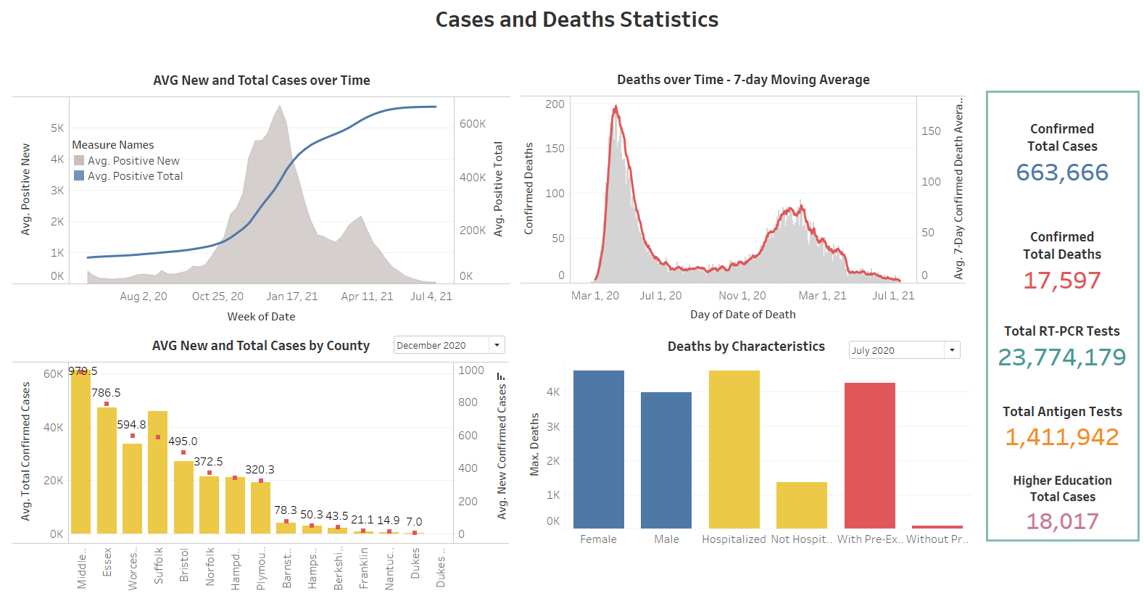

Confirmed cases in educational institutions and Massachusetts state

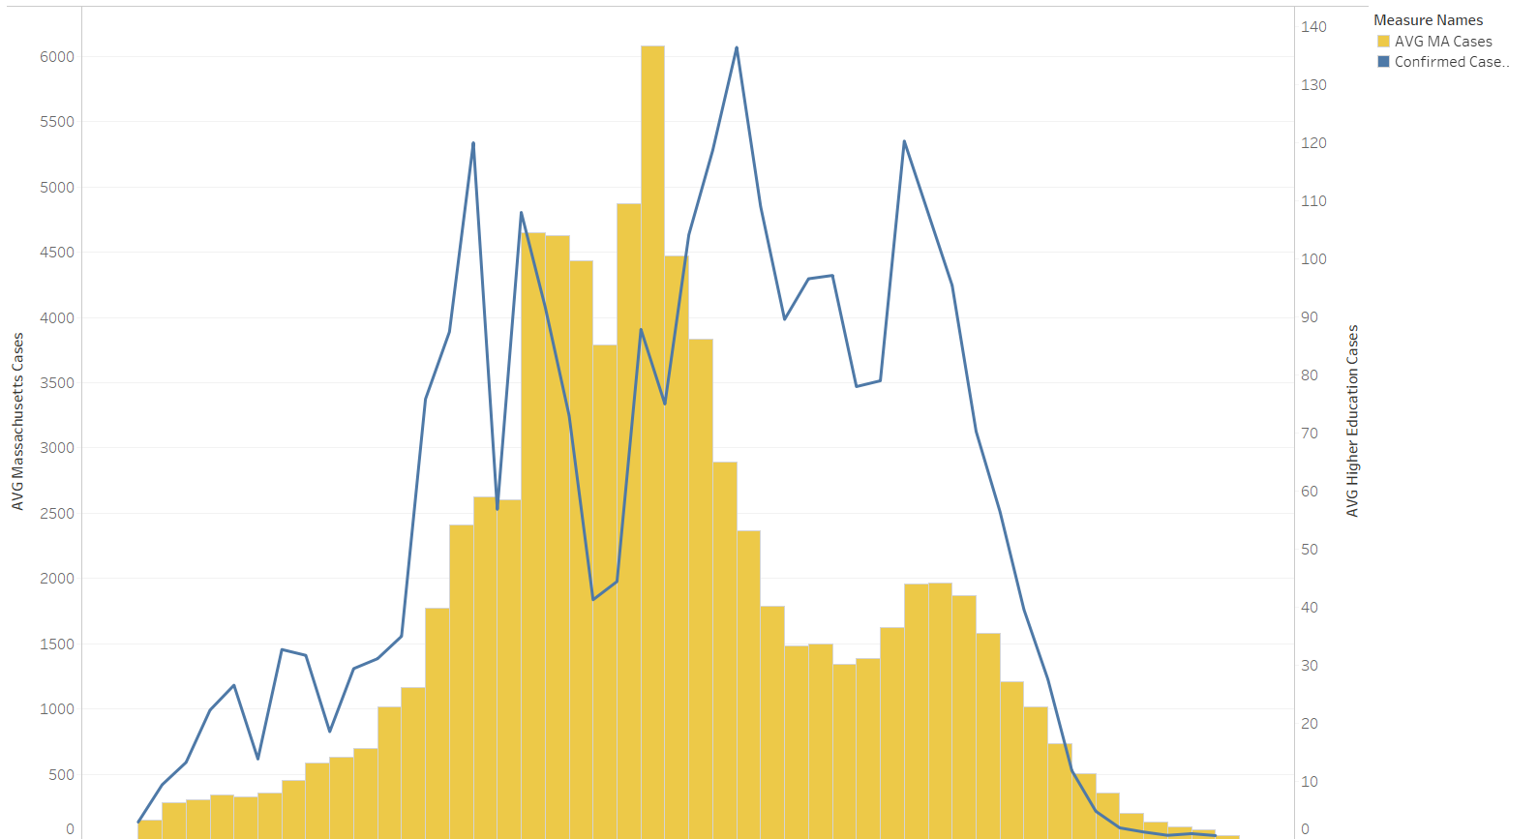

**Covid-19 trends and situation analysis**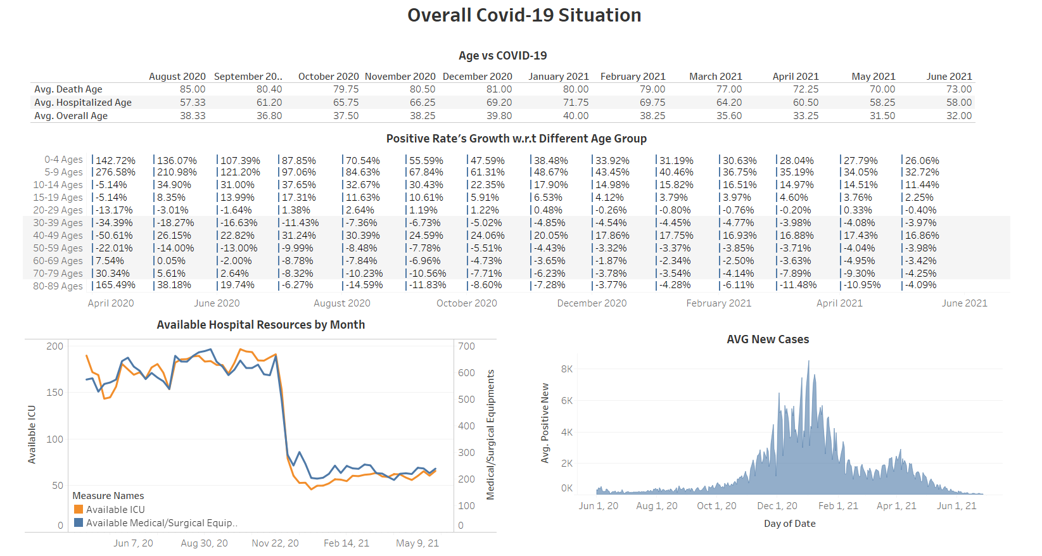

Isolation and Hospitalization analysis



Vaccine Analysis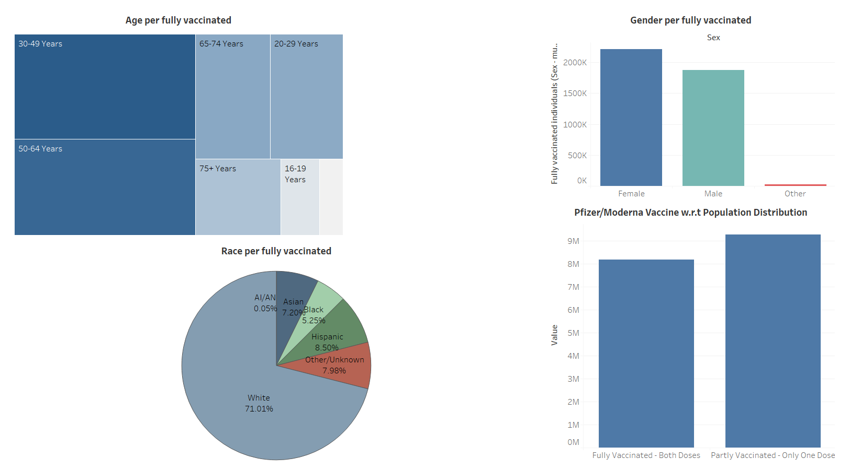

**Conclusion**

The dashboard analysis contains data that is very crucial to decide some important business questions for the Student Health Centre. The data is presented in a visually attractive and interactive format where the end user can change different parameters to get a more granular view of data. This will help target a particular age group, race, county and particular month of the year and make comparisons to see how the trends in data have changed and how the public health conditions have worsened or improved. This helps business owners target specific questions related to health concerns in the student community.

**References**

[1] Hadley, C. (2018, January 22). 3 benefits of interactive visualization. Retrieved July 3, 2021 from <https://campus.sagepub.com/blog/3-benefits-of-interactive-visualization>

[2] Pandey, P. (2018, September 24). Data Visualization with Tableau. Retrieved July 3, 2021 from <https://www.datacamp.com/community/tutorials/data-visualisation-tableau>

[3] USAFacts. (2021, July 1). Massachusetts Coronavirus Vaccination Progress. Retrieved July 3, 2021 from <https://usafacts.org/visualizations/covid-vaccine-tracker-states/state/massachusetts>

[4] Blumenstein, H. (2021, April 23).Data analytics and intelligence tools to play a key role post Covid-19. Retrieved July 3, 2021 from

<https://cloud.google.com/blog/products/data-analytics/post-covid-data-analytics-and-intelligence-tools>

[5] Indeed Editorial Team. (2021, April 2). A complete guide to Key Performance Indicators (KPIs). Retrieved July 3, 2021 from

<https://www.indeed.com/career-advice/career-development/key-performance-indicators>